Session 4:

CREATE TABLE Playlist (id int PRIMARY KEY AUTO_INCREMENT,songname varchar(50),artist varchar(20),genre varchar(30),playcount int);

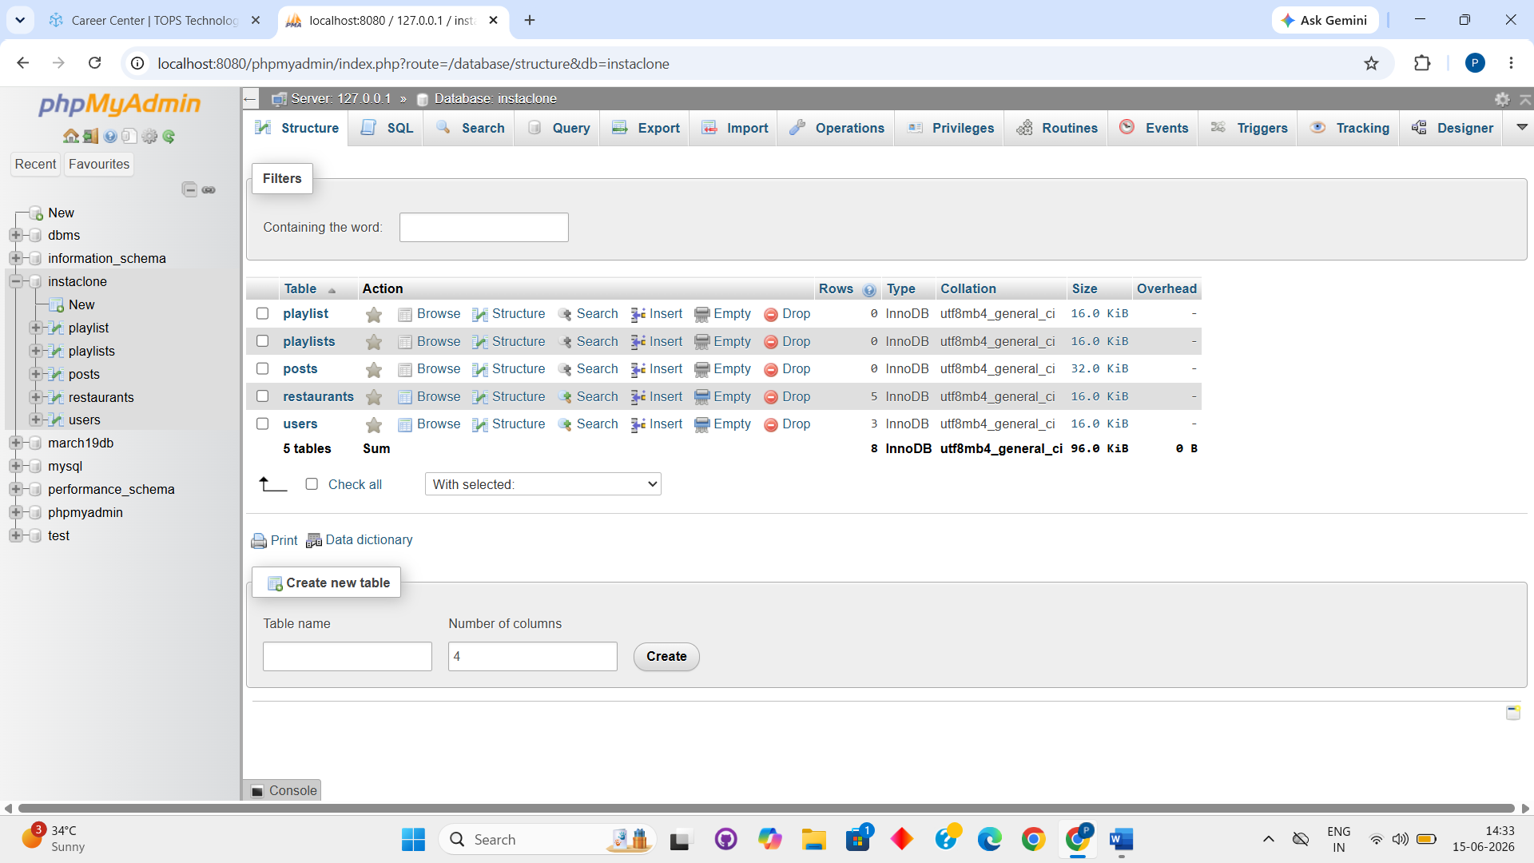

INSERT INTO playlist (songname, artist, genre, playcount) VALUES
('Blinding Lights', 'The Weeknd', 'Pop', 250),
('Shape of You', 'Ed Sheeran', 'Pop', 300),
('Believer', 'Imagine Dragons', 'Rock', 180),
('Levitating', 'Dua Lipa', 'Pop', 220),
('Stay', 'The Kid LAROI & Justin Bieber', 'Pop', 270);

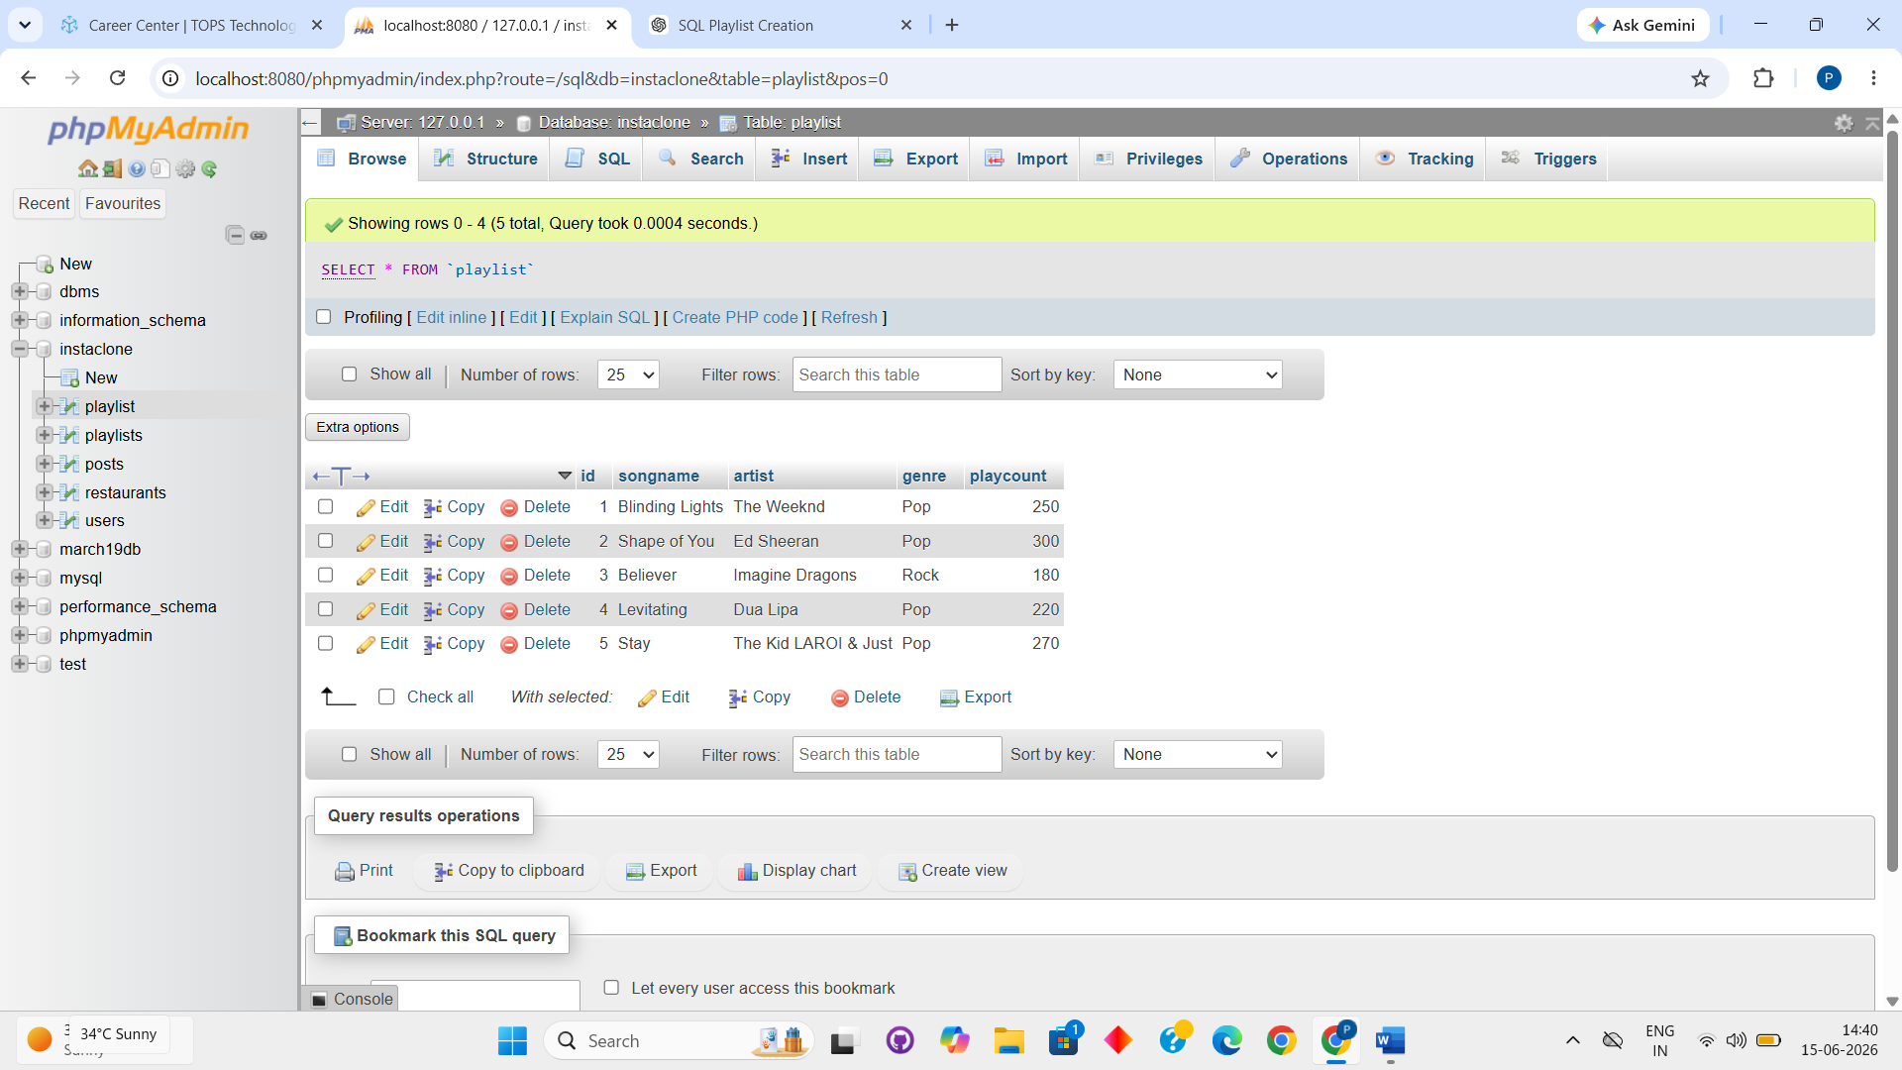

SELECT songname, artist as Singer FROM playlist;

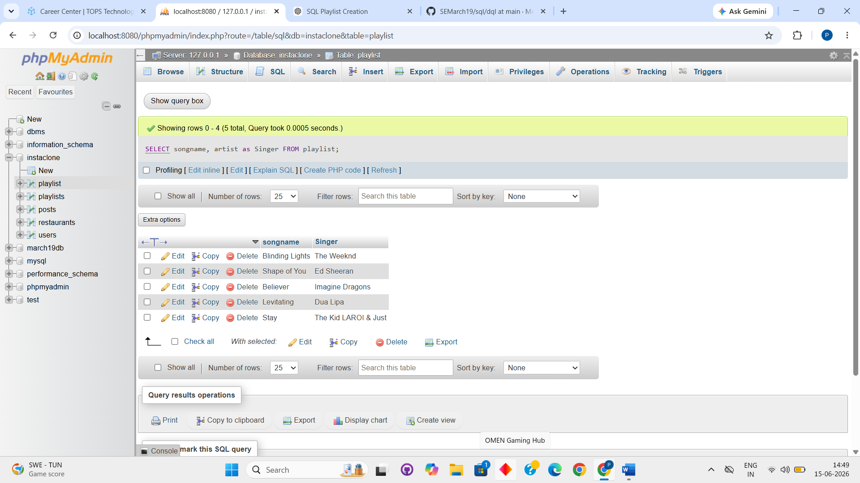

SELECT * FROM `playlist` WHERE genre="Pop" AND playcount>=100;

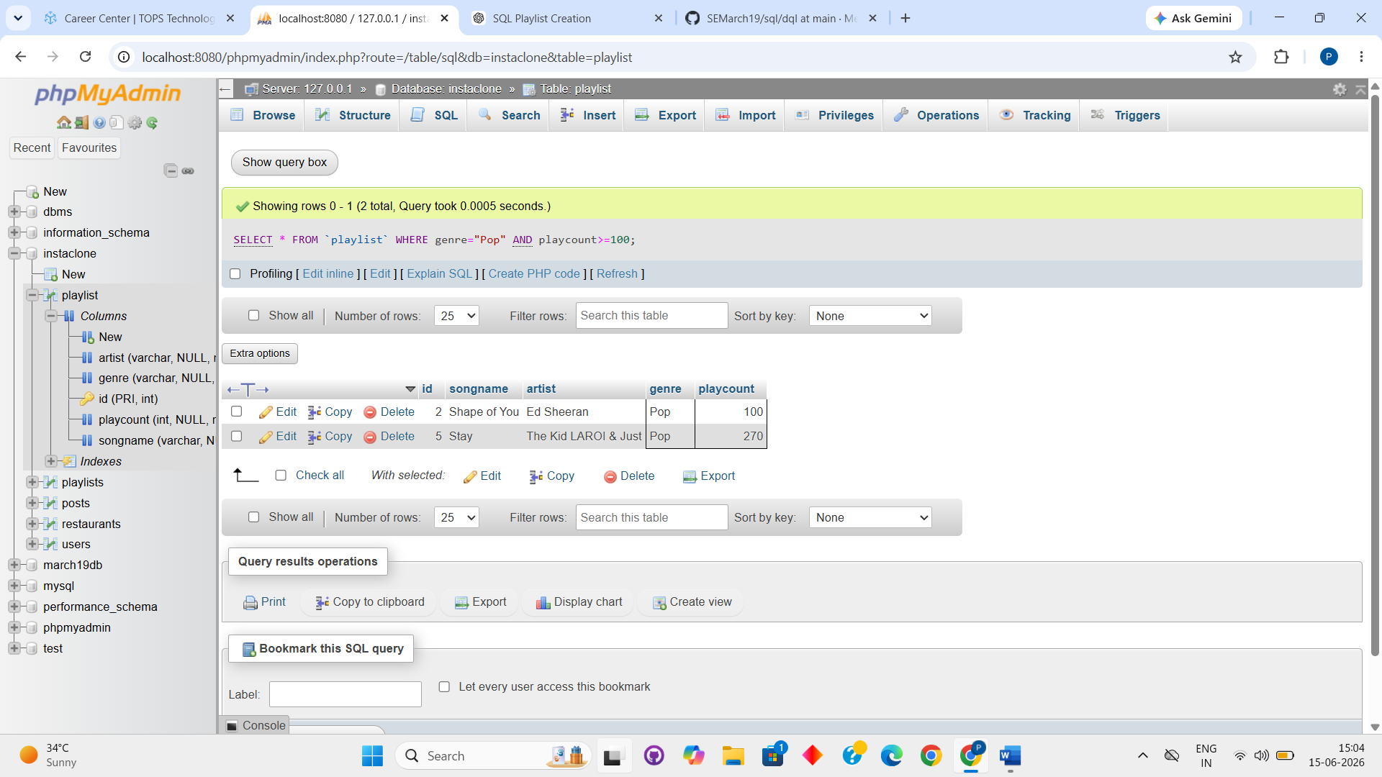

SELECT COUNT(*)
FROM Playlist
WHERE genre = 'HipHop';

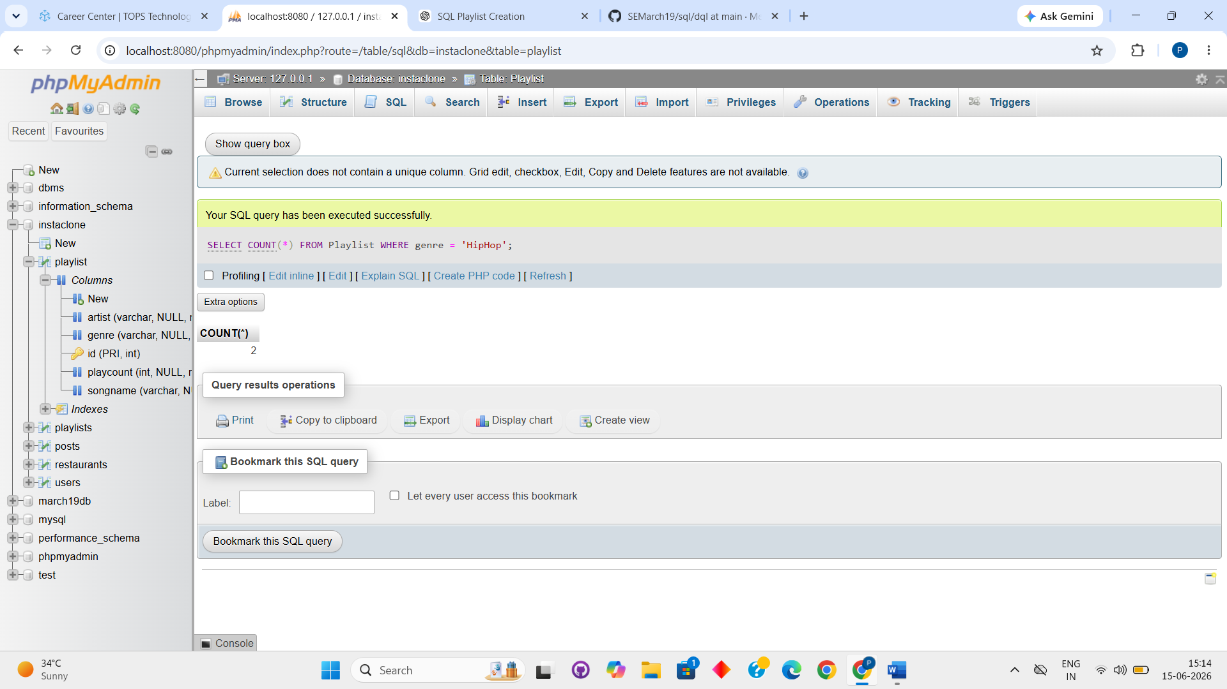

SELECT genre, SUM(playcount) FROM playlist GROUP BY genre;

